**Unit 9 Aggregate Functions**

Corey Crooks

Purdue University Global

IT163 – Kathi Nicholson

April 28, 2021

**Using built-in and aggregate functions, show the total quantity of sales by month**

SELECT MonthName(Month([SaleDate])) AS [Month], tblSales.SaleDate, tblSalesLineItems.Quantity

FROM tblSales INNER JOIN tblSalesLineItems ON tblSales.InvoiceNumber = tblSalesLineItems.InvoiceNumber;

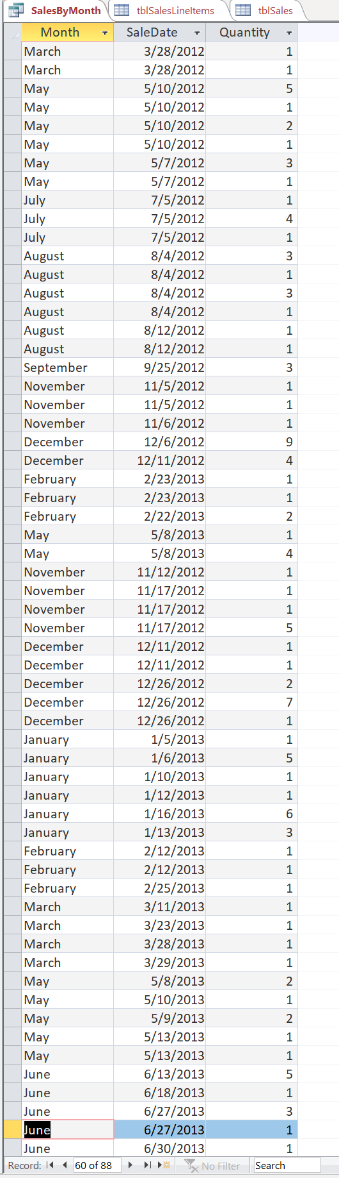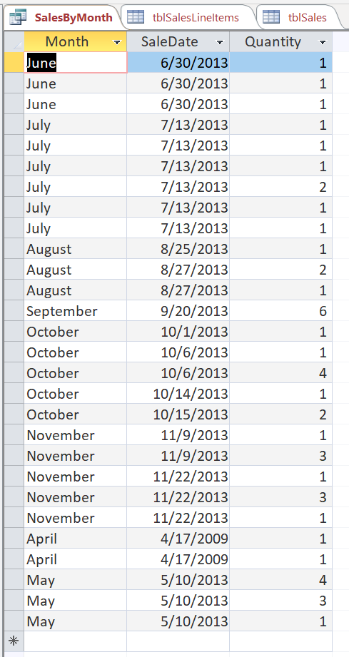

2nd

1st

**Incorporate a calculation within a field in a query that will reflect a 10% reduction in retail price for all Products from the Products table.**

SELECT tblProducts.Description, ([RetailPrice]*0.9) AS SalePrice, tblProducts.RetailPrice AS OrigPrice

FROM tblProducts;

2nd

1st

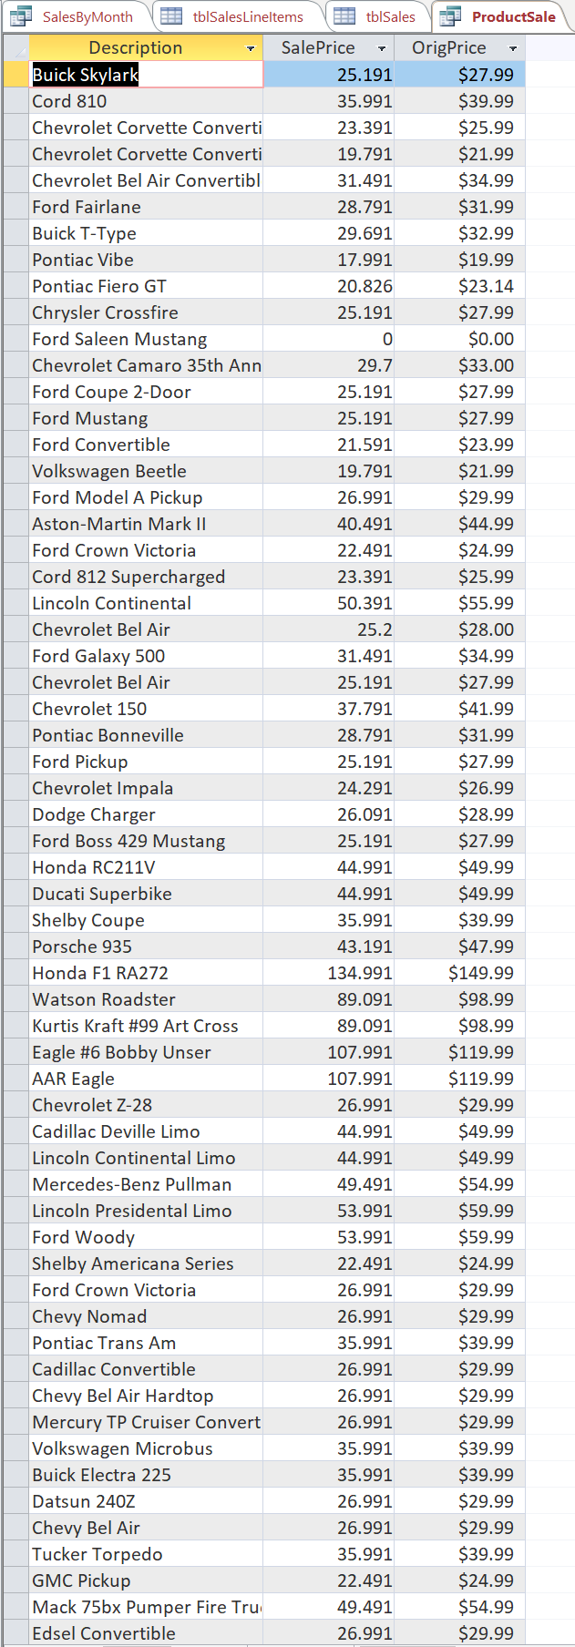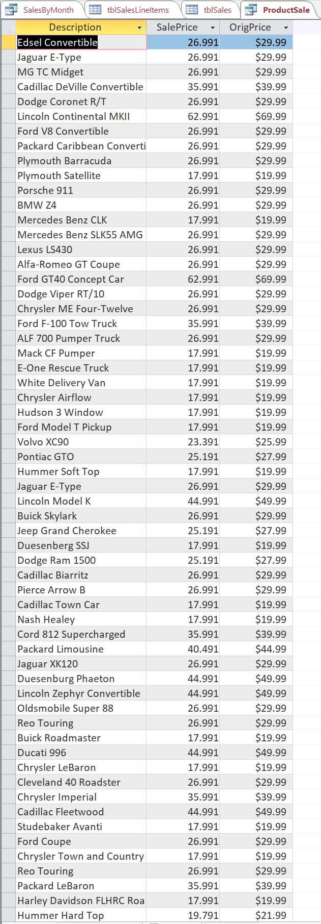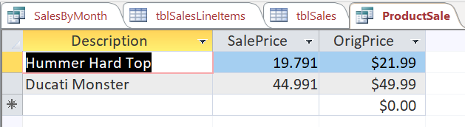

3rd

**Sometimes we want to allow the user to interact with the query rather than using fixed values in the where clause. We can do this with a parameter query.**

SELECT tblCustomers.Company, tblCustomers.State

FROM tblCustomers

WHERE tblCustomers.State = [Only Show Which State?];

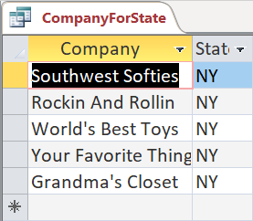

Input = ‘NY’

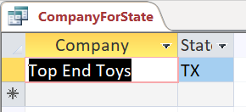

Input = ‘TX’

**Let’s look at an action query this time. One of the customers has a misspelling in their company name and we want to correct the data in the table.**

UPDATE tblCustomers SET tblCustomers.Company = 'Terrific Toys'

WHERE tblCustomers.Company = 'Terriffic Toys';

